

**Data Visualization on UK Bank customer data using Tableau dashboards**

DATA 230 - Data Visualization for Data Analytics, Department of Applied Data Science

San Jose State University, California

Submitted By – Parth Tiwari

Enrollment Number- 016668860

Table of Contents

1. Introduction

1.1 Purpose of this document

1.2 Intended Audience

1.3 Scope

1.4 Definitions and acronyms

1.4.1 Definitions

1.4.2 Acronyms and abbreviations

1.5 References

2. Customers

3. Development process

*4.* Deliverable

5. Git

6. Project plan- Time schedule

7. Reference

10. worksheet

11. Dashboard

12. story

# Introduction

## Purpose of this document

The purpose of this document is to provide a detailed project description of the dashboard called UK bank customer data analysis, which is designed on customer data of a bank in the United Kingdom which shows region wise job classification, gender wise job classification percentage.

## Intended Audience

This document shall be used in the Analysis phases of the project as a guideline. Intended audiences of this project are all project stakeholders:

* project supervisor
* project leader
* team members

## Scope

This document defines the project plan of the UK bank customer data analysis dashboard. Analyze a UK Bank customer demographic across geographical locations between nation states using Tableau. In this analysis my duties as a Data Analyst for a UK Bank was to create a dashboard that analyzes customer segmentation based on region.

The overview includes objectives of the project, organization of the project team, development process that is going to be used during the project, assessment of possible risks, communication used between project stakeholders and project plan that includes time schedule and activity plan.

## Definitions and acronyms

### Definitions

|  |  |
| --- | --- |
| **Keyword** | **Definitions** |
| <Name> | The name of the project |
| Project Supervisor | A person in charge of supervising the project |
| Project Leader | A person in charge of organizing the team and communicating with the project supervisor |
| Team Member | An active member of the team responsible for making the job done |
| Milestone | A time in a project that marks the end of a project phase or the completion of an important deliverable. |
| Git | Version control system that will be used in this project |
| Scrum | An iterative and incremental agile software development method for managing software projects and product or application development |
| Tableau | Tools which is used to create dashboards |
| Scrum sprint | The basic unit of development in Scrum |
| Scrum master | Ensures the smooth working of the Scrum team and enforces Scrum practices |
| Product owner | Responsible for product management and its quality |

### Acronyms and abbreviations

|  |  |
| --- | --- |
| **Acronym or**  **abbreviation** | **Definitions** |
| uk | United Kingdom |
| Cc | Credit card |

## References

1. <https://public.tableau.com/views/>
2. <https://www.kaggle.com/datasets/ukveteran/uk-bank-customers/>

# Customer

The target customers are listed below:

* 1 Bank existing Customer
* 2 UK targeted people

# Development process

The project will use tableau, to build a dashboard that aids in finding the story hidden in the data. Tableau is very effective software that is used to build an interactive dashboard which helps in finding the story hidden in the data and helps in the data analysis. It includes a drag-and-drop interface that is very easy to use and creative dashboards are created very quickly. The dashboard will show insight of customer segmentation based on region.

## Git

All source code and finished documentation will be uploaded to GitHub repository.

Repository URL: https://github.com/parth0309/Data-Visualization-project-Parth-Tiwari.git

# Project plan

## Time schedule

|  |  |  |  |  |  |  |  |  |
| --- | --- | --- | --- | --- | --- | --- | --- | --- |
| **Id** | **Milestone**  **Description** | **Finished Date** |  |  |  | **Metr.** | **Rem.** |  |
|  |  | **Plan** | **Forecast** |  | **Actual** |  |  |  |
|  |  |  | **Data** | **+/-** |  |  |  |  |
| 1 | Finding the data sources | 10/05/2022 | **10/05/2022** |  |  |  |  |  |
| 2 | Data Wrangling | 10/12/2022 | **10/12/2022** |  |  |  |  |  |
| 3 | Build the dashboard | 10/29/2022 | **10/29/2022** |  |  |  |  |  |
| 4 | Build a story to presend | 11/20/2022 | **11/20/2022** |  |  |  |  |  |
| 6 | Project Report | 11/30/2022 | 11/30/2022 |  |  |  |  |  |
| 7 | 15-minute live project demonstration | 12/06/2022 | 12/06/2022 |  |  |  |  |  |

# References

<https://public.tableau.com/app/discover>

https://www.kaggle.com/datasets/ukveteran/uk-bank-customers

**Data Process**

The area of the United Kingdom is divided into the four regions of England, Northern Ireland, Scotland, and Wales for the purposes of the comparison by region. The filter for other attributes will be these areas.

* There are four regions in the entire data set.
* The filter is based on the map's four regions.
* the data's distribution by gender, age, and job category.

**United Kingdom customer-base**

By reorganizing the data to represent the regions' precise locations on the world map, the UK customer map was produced. Then I added a color scale to distinguish each section according to color, along with a legend for guidance. The total number of clients in each region was also added. In the following worksheets, I've created filters to make it easier to specify each region. This map is essential to the dashboard since clicking on each location on the map to access customer segmentation information makes it more dynamic.

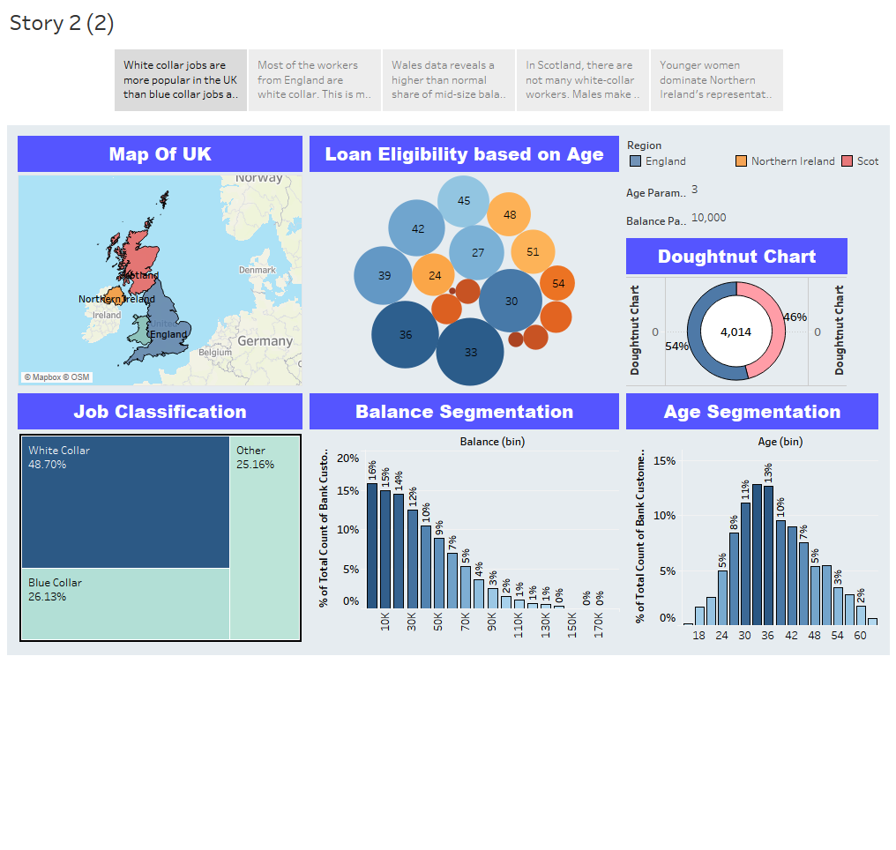

**Gender Chart**

This pie chart displays the gender to study the various demographics in each region. Once this worksheet is added to the dashboard, filters were added to allow the pie chart to modify based on region.

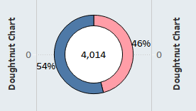

Age Segmentation

I made a graph that shows how many clients are spread out among the various age groups. To make an interactive dashboard, I incorporated filters. The age groups were also grouped by precise age, every 2, 3 and 5 years.

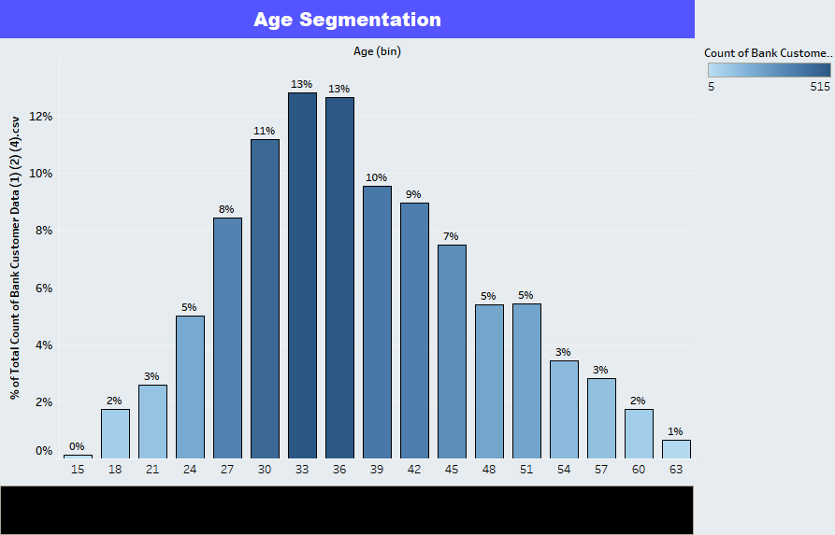

Balance Segmentation

I made a chart that shows the proportion of clients that have a certain amount of money in their bank accounts. You can use this graph to see how balances are distributed among the dashboard's various regions. For the purpose of analyzing the various distribution sizes of the bank's client accounts, the customer balances were grouped into bins ranging from $5,000 to $25,000.

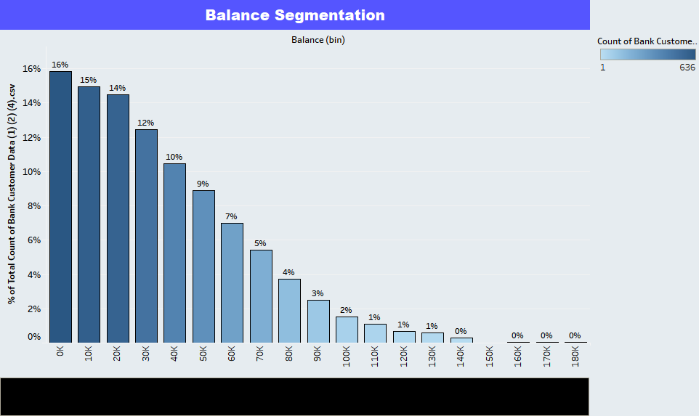

Job Classification

I made a tree graph to show how each customer's employment is classified by the bank. You can analyze the changes in job classification by region once this is in the dashboard.

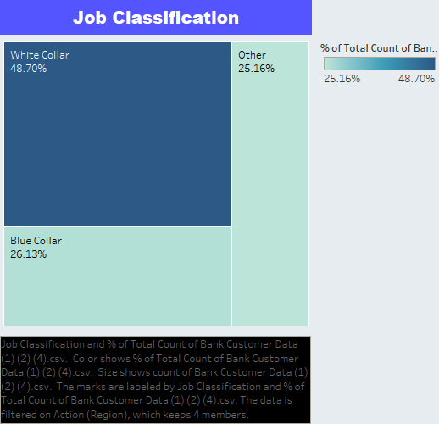

Dashboard

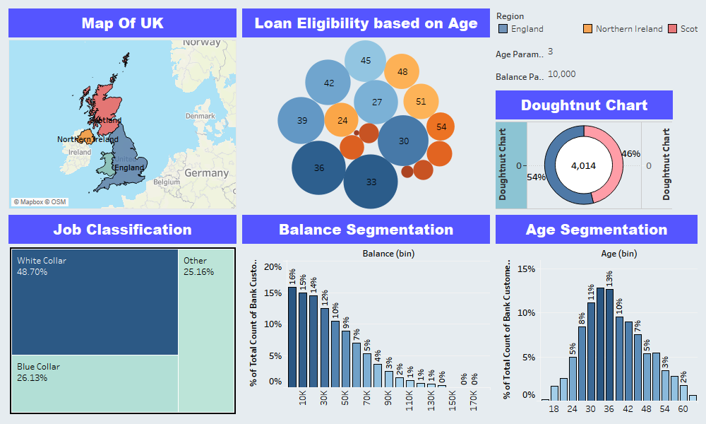

Story-

1. Majority of customers in England do white-collar jobs

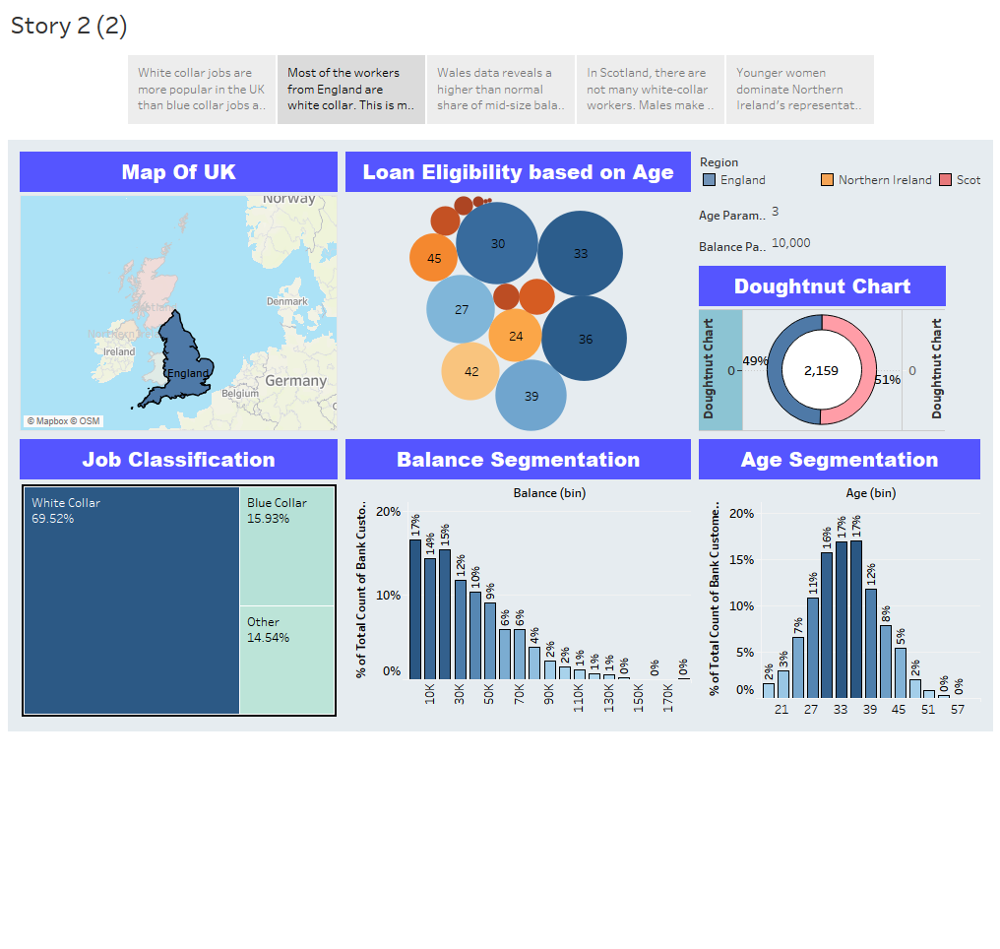

1. Wales data reveals a higher than normal share of mid-size balances. People who are 33 to 35 years old are highly eligible for loans. This is so because people at this age are young and prosperous and have good credit score.

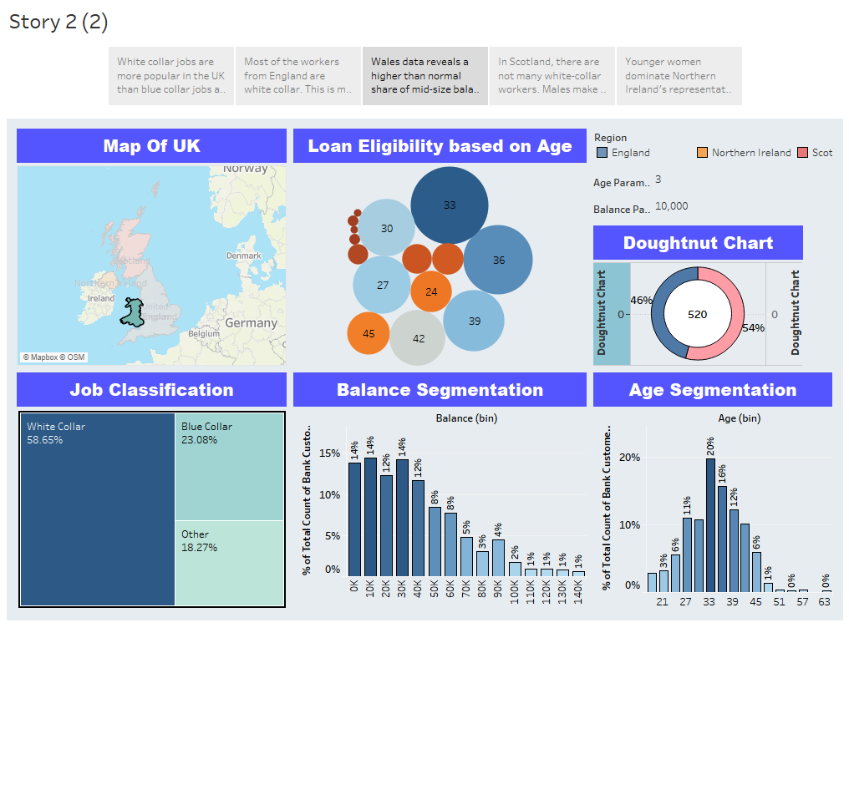

1. In Scotland, there are not many white-collar workers. Males make up about 72% of the customer base.

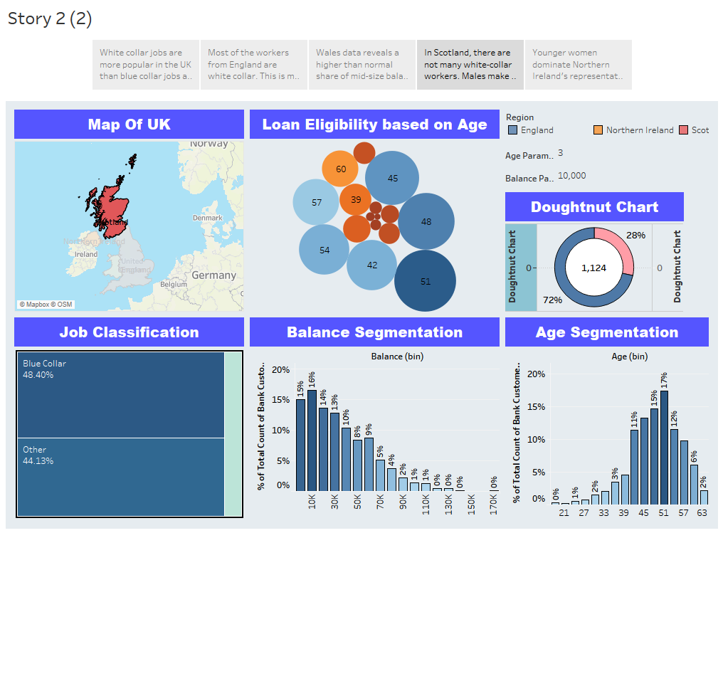

1. Younger women dominate Northern Ireland's representation, and young people have a greater chance of readily qualifying for a loan.

